Virtual Cabinet

How to download documents & Sign

When you click on the link sent by Fairey Associates you will see page as shown below: (It will have your name as a client on it). There will be a Green Button at the top that will prompt you to sign, once this is signed this will be received as our confirmation.

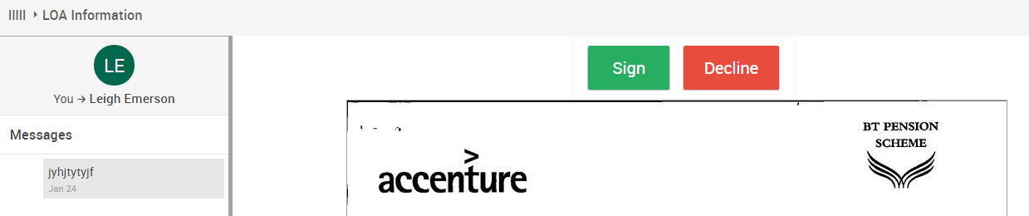

To Download you documents you will need to complete the following:

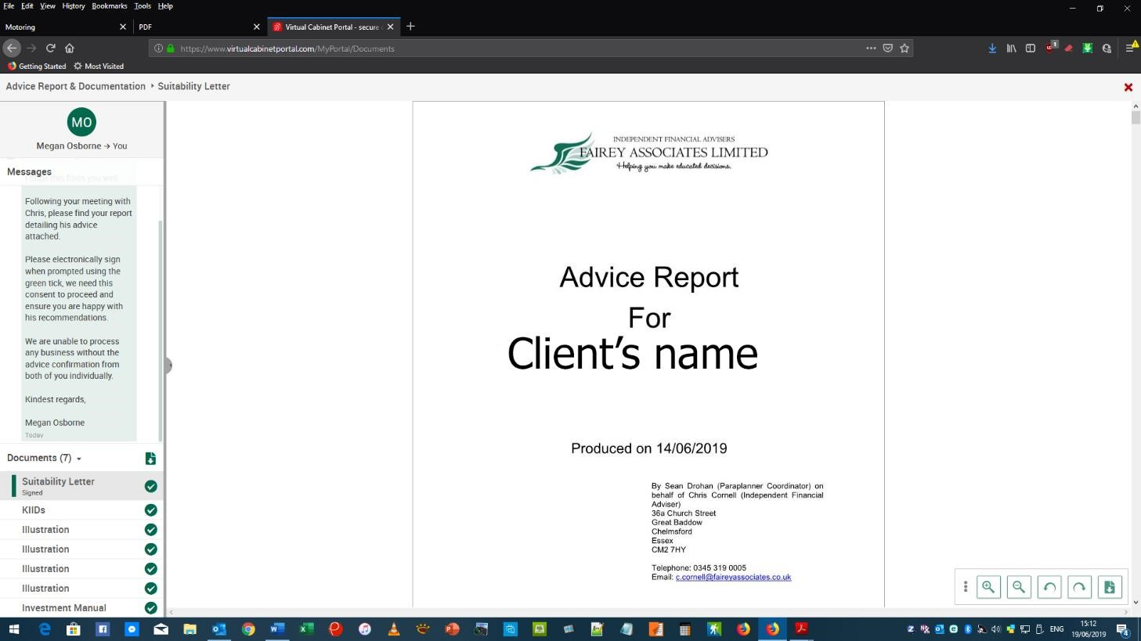

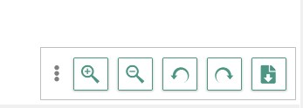
In the RH corner are some navigation buttons:

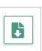
If you click on the RH button with the ‘down arrow’ symbol on it this will download the document that you have selected from the list on the LH side column such as Suitability Letter. (This symbol is a typical download icon on many systems for downloading files etc.).

The file will be downloaded in PDF format that is easily printed. It can be read later provided you have the free Adobe PDF Reader installed. (This can be found at: https://get.adobe.com/uk/reader/)

